# Activity 1.2.2

Consider the following extract of a table and **identify the problems with the data**:

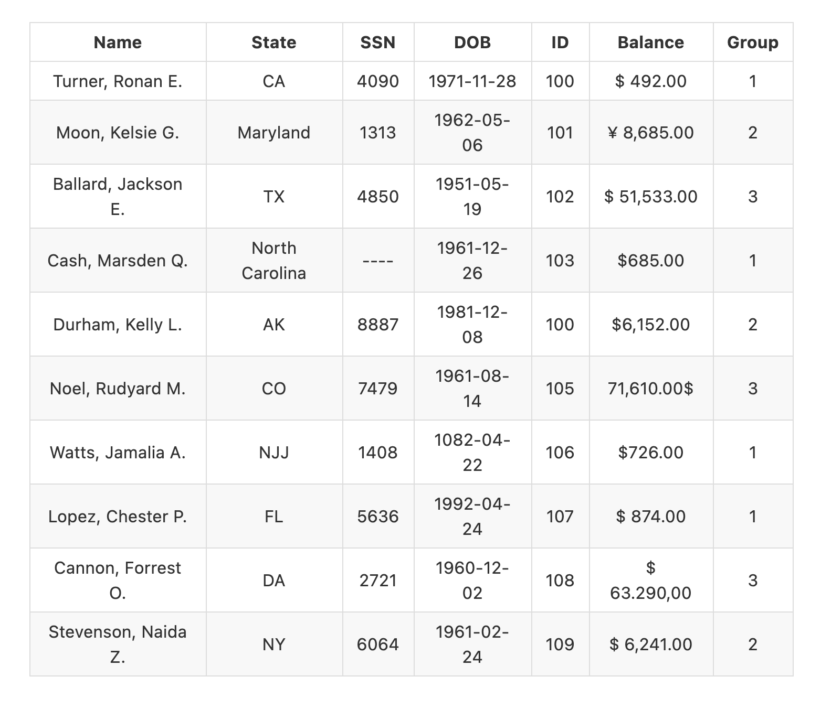

· Copy the table into an excel sheet and try to identify the problems in the data with a conditional cell:

* Missing data with yellow
* Wrong data type with red
* Miss type error with light blue
* Duplicate value with orange
* Not normalized data green